WEEK – 2

Exercise 1: Logging Error Messages and Warning Levels

Nipuna.A

Superset id:6432842

Task: Write a Java application that demonstrates logging error messages and warning levels using SLF4J.

**Step-by-Step Solution:**

1. Add SLF4J and Logback dependencies to your `pom.xml` file:

<dependency>

<groupId>org.slf4j</groupId>

<artifactId>slf4j-api</artifactId>

<version>1.7.30</version>

</dependency>

<dependency>

<groupId>ch.qos.logback</groupId>

<artifactId>logback-classic</artifactId>

<version>1.2.3</version>

</dependency>

1. Create a Java class that uses SLF4J for logging:

import org.slf4j.Logger;

import org.slf4j.LoggerFactory;

public class LoggingExample {

private static final Logger logger = LoggerFactory.getLogger(LoggingExample.class);

public static void main(String[] args) { logger.error("This is an error message"); logger.warn("This is a warning message");

}

}

Solution:

Src\main

Java\com\example

1)LoggingExample.java

package com.example;

import org.slf4j.Logger;

import org.slf4j.LoggerFactory;

public class LoggingExample {

    private static final Logger logger = LoggerFactory.getLogger(LoggingExample.class);

    public static void main(String[] args) {

        logger.error("This is an error message");

        logger.warn("This is a warning message");

    }

}

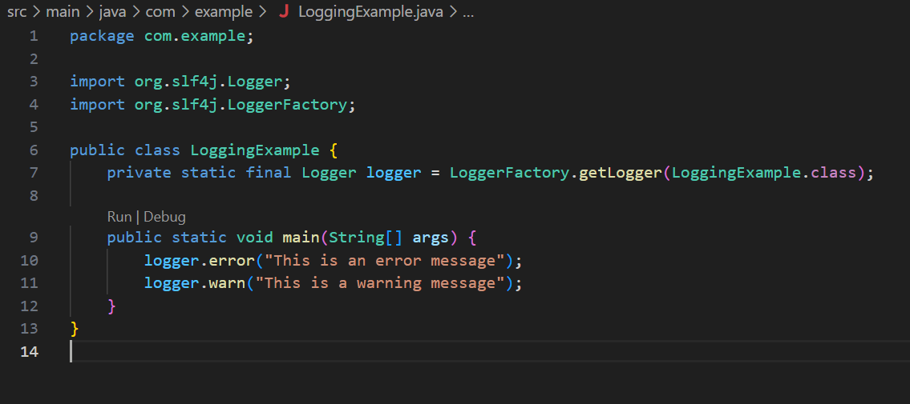

Resources

2)logback.xml

<configuration>

    <appender name="STDOUT" class="ch.qos.logback.core.ConsoleAppender">

        <encoder>

            <pattern>%d{HH:mm:ss.SSS} [%thread] %-5level %logger{36} - %msg%n</pattern>

        </encoder>

    </appender>

    <root level="debug">

        <appender-ref ref="STDOUT"/>

    </root>

</configuration>

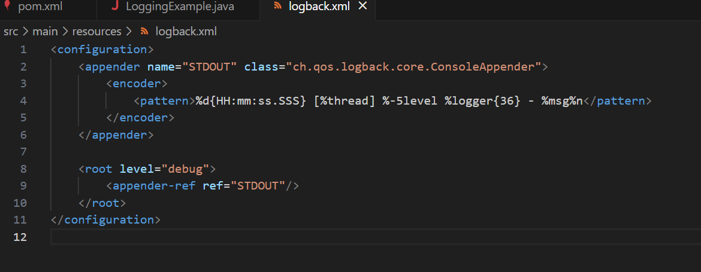

3)pom.xml

<project xmlns="http://maven.apache.org/POM/4.0.0"

         xmlns:xsi="http://www.w3.org/2001/XMLSchema-instance"

         xsi:schemaLocation="http://maven.apache.org/POM/4.0.0 http://maven.apache.org/xsd/maven-4.0.0.xsd">

    <modelVersion>4.0.0</modelVersion>

    <groupId>com.example</groupId>

    <artifactId>LoggingExample</artifactId>

    <version>1.0-SNAPSHOT</version>

    <dependencies>

        <!-- SLF4J API -->

        <dependency>

            <groupId>org.slf4j</groupId>

            <artifactId>slf4j-api</artifactId>

            <version>1.7.30</version>

        </dependency>

        <!-- Logback implementation -->

        <dependency>

            <groupId>ch.qos.logback</groupId>

            <artifactId>logback-classic</artifactId>

            <version>1.2.3</version>

        </dependency>

    </dependencies>

    <build>

        <plugins>

            <plugin>

                <groupId>org.codehaus.mojo</groupId>

                <artifactId>exec-maven-plugin</artifactId>

                <version>3.1.0</version>

                <configuration>

                    <mainClass>com.example.LoggingExample</mainClass>

                </configuration>

            </plugin>

        </plugins>

    </build>

</project>

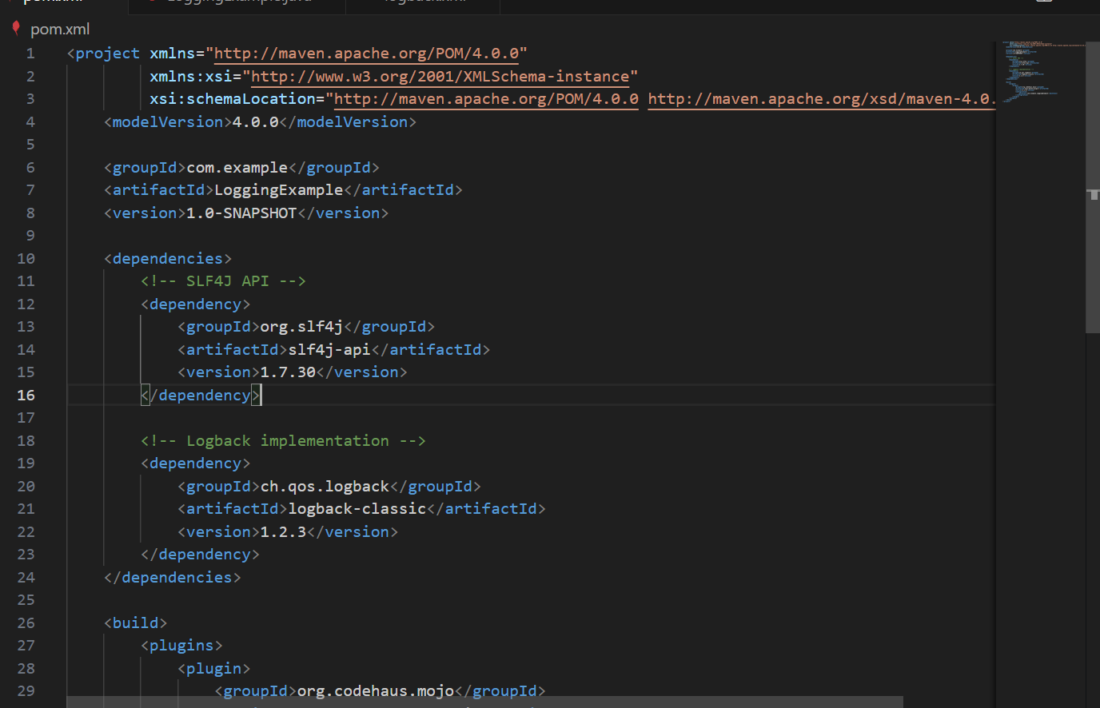

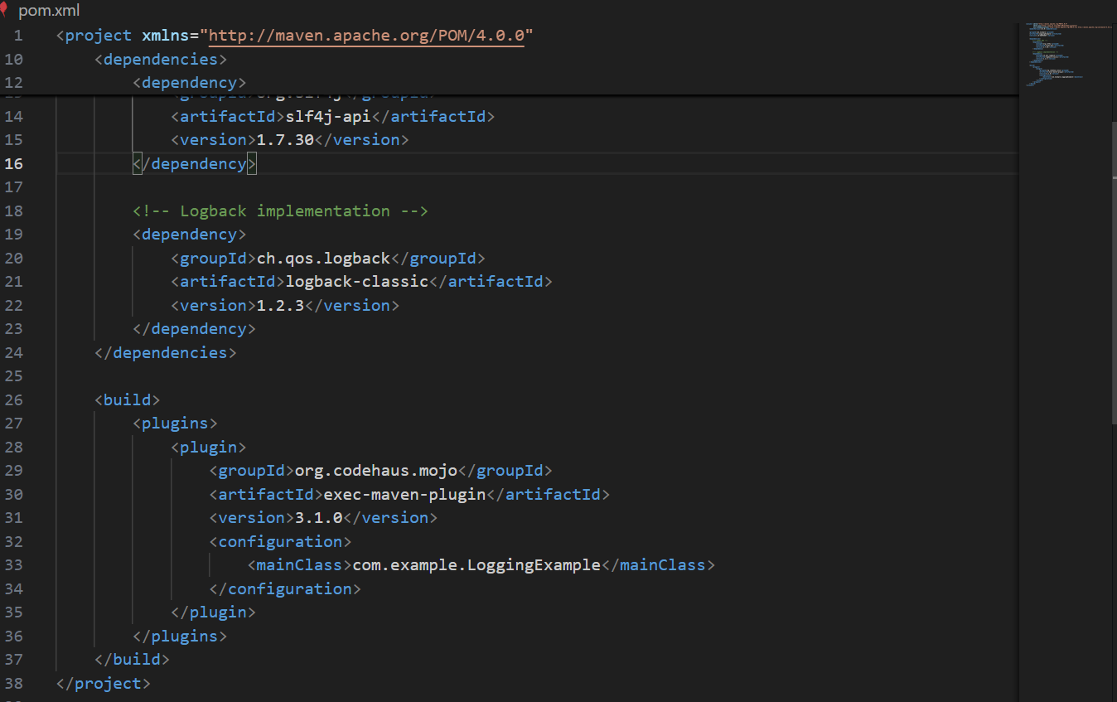

Output:

